Business Case for Health Metrics Project

Team Members –

Jayesh Pamnani

Manav Gupta

Kunal Haryani

William Dzialak  
Bhanu Teja Panguluri

University of Maryland

7950 Baltimore Avenue

College Park, MD 20742

5th March, 2024

1. **Executive Summary**

In the current era, where maintaining health and wellness is of utmost importance, there exists a growing demand for a sophisticated health metrics tracking application. This software is a personal health companion for any general user. By integrating features such as calorie estimation from meal photos, and compatibility with various health monitoring devices, the application offers a multifaceted approach to health management.

The application aims to revolutionize how individuals track their health metrics – calorie intake, water consumption, exercise, steps, heart rate, blood pressure, and stress levels. It will not only gather data but also provide users with in-depth analyses of their health trends, fostering a proactive attitude toward health maintenance.

The development of this application aligns with current health management trends and taps into a market with immense potential. The application promises substantial market share and user engagement by empowering users with detailed insights and control over their health data. The projected return on investment is bolstered by the application's broad appeal and the growing public interest in health and fitness technologies.

1. **Introduction**
   1. **Background**  
      The global health and wellness market is witnessing unprecedented growth, driven by increasing awareness of the importance of health and preventive measures. Within this context, NutriScope is introduced as a solution to fill the gap in comprehensive, user-friendly health-tracking technologies. This application is designed to cater to a broad audience, from fitness enthusiasts to individuals monitoring specific health conditions, offering an all-in-one platform for health data tracking and analysis.
   2. **Current situation**

Currently, the market is saturated with various health-tracking apps focusing on specific health metrics like steps taken, calories burned, or heart rate monitoring. However, there exists a notable gap in the market for a holistic health-tracking solution that combines all these features with advanced functionalities like meal photo-based calorie estimation and seamless device integration. This gap represents a significant opportunity for NutriScope to differentiate itself and capture market share.

* 1. **Description of the problem and opportunity**

Most health-tracking tools available today offer fragmented solutions that require users to use multiple platforms for comprehensive health monitoring. This fragmentation results in inconvenience and reduces the consistency in tracking, ultimately affecting the user's ability to make informed health decisions. NutriScope addresses this problem by integrating various health metrics into a single platform, providing users with a convenient and comprehensive tool for monitoring and improving their health. The opportunity lies in leveraging advanced technology to offer unique features that enhance user experience and engagement, setting a new standard in the health app market.

* 1. **MOV**  
     The Measurable Organizational Value (MOV) for NutriScope is centered around enhancing user engagement, expanding market reach, facilitating cost savings, improving health outcomes, achieving financial goals, and securing a positive return on investment. Specifically, it targets a 25% increase in user engagement within the first year, aims to attract 100,000 daily active users by the end of the second year, and seeks to enable users to achieve an average of 10% in health-related cost savings. Additionally, it aspires to witness a 10% improvement in key health metrics among users by the third year and reach a positive ROI within the same timeframe. These objectives collectively underscore the application's ambition to deliver substantial value to users and stakeholders, positioning it as a transformative tool in the health and wellness market.
  2. **How Achieving the project’s MOV will support the organization’s goal and strategy** Achieving the project's Measurable Organizational Value (MOV) aligns closely with the organization's overarching goals and strategy, especially in the health and wellness sector. By enhancing user engagement, expanding the user base, facilitating cost savings, and improving health outcomes, NutriScope directly contributes to the organization's mission to empower individuals to lead healthier lives through innovative technology solutions.

The increase in user engagement and market penetration supports the goal of becoming a leader in the health tech industry, showcasing the organization's commitment to delivering high-quality, impactful products. The financial targets, including revenue generation and achieving a positive return on investment within three years, align with the strategic objective of sustainable growth and profitability. Furthermore, the focus on improving health metrics among users not only demonstrates the application's tangible benefits but also strengthens the organization's reputation as a contributor to public health improvements.

In essence, realizing the MOV of NutriScope embodies the organization's strategy to innovate within the health and wellness space, creating a significant impact on users' lives while ensuring financial viability and market leadership. This strategic alignment ensures that the project's success is not just measured by its direct outcomes but also by its contribution to the broader organizational vision of enhancing health and wellness through technology.

1. **Alternatives**
   1. **Alternative 1: Standalone Health Tracking Mobile App**

A standalone mobile app represents a focused, user-friendly approach to health metrics tracking, designed for quick deployment and ease of use. While it offers the advantage of lower initial development costs and faster market entry, its primary drawback lies in its limited scope. This alternative might not fully satisfy users seeking comprehensive health management tools, potentially impacting long-term user engagement and retention. Nevertheless, it could serve as a valuable entry point into the market, allowing for iterative improvements based on user feedback.

* 1. **Alternative 2: Web-Based Platform**

The web-based platform alternative emphasizes accessibility and ease of maintenance, enabling users to access their health metrics from any device with internet connectivity. This approach eliminates the need for app downloads, providing a seamless experience across platforms. However, it may face challenges in delivering the same level of engagement and responsiveness as native apps, and its reliance on internet access could limit usability in areas with poor connectivity. Despite these challenges, its broader accessibility makes it an attractive option for users prioritizing convenience.

* 1. **Alternative 3: Partnership with Existing Health Platforms**

Forming a partnership with existing health platforms offers a strategic shortcut to market presence, leveraging established user bases and infrastructures. This route significantly reduces development time and costs but at the expense of full product control and potential revenue sharing. The success of this alternative heavily relies on the strength of the partnership and the ability to integrate effectively, offering a balanced blend of both entities' strengths to the end user. While promising rapid market penetration, it poses risks related to dependency and brand dilution.

* 1. **Alternative 4: AI-Integrated Health Metrics Application**

The proposed AI-Integrated Health Metrics Application aims to provide a comprehensive solution, combining innovative features like meal photo-based calorie estimation with extensive health metric tracking and graphical analysis of health trends. This approach addresses the market's need for an all-encompassing health management tool, potentially setting a new industry standard. The major challenges include higher development and maintenance costs and a longer time to market. However, its potential to significantly enhance user engagement and provide actionable health insights justifies the investment, offering a strong value proposition in the growing health and wellness market.

1. **Analysis of Alternatives**
   1. **Data Collection & Metrics**  
      To create an analysis of the alternatives table for the Health Metrics Application, the criteria will be weighted based on their importance to the project's success. For this analysis, let's consider the following criteria:
2. **C1: User Engagement & Market Reach** - The ability of the alternative to engage users and capture market share.
3. **C2: Development Cost & Time** - The cost and time required to develop the alternative.
4. **C3: Feature Set & Health Impact** - The comprehensiveness of features and the potential impact on users' health.
5. **C4: Financial Performance** - The alternative's potential to generate revenue and achieve a positive ROI.
   1. **Alternative Analysis**

|  |  |  |  |  |  |
| --- | --- | --- | --- | --- | --- |
| Criteria | Weight | Alternative 1 (Standalone Tracking App) | Alternative 2 (Web-Based Platform) | Alternative 3 (Partnership) | Alternative 4 (AI-Integrated App) |
| C1: User Engagement & Market Reach | 30% | 70 | 60 | 80 | 90 |
| C2: Development Cost & Time | 20% | 80 | 70 | 90 | 60 |
| C3: Feature Set & Health Impact | 30% | 60 | 50 | 70 | 100 |
| C4: Financial Performance | 20% | 75 | 65 | 55 | 85 |
| Total |  | 70 | 60 | 74 | 86 |

**Note: Higher Risk values represent low risk.**

* + 1. **Alternative 1 (Standalone App)** scores well in development cost and time but falls short in user engagement, feature set, and financial performance when compared to the proposed solution.
    2. **Alternative 2 (Web-Based Platform)** shows moderate scores across all criteria but does not excel in any area, indicating a balanced but not outstanding option.
    3. **Alternative 3 (Partnership)** scores highest in development cost and time due to shared resources but lags in the feature set and financial performance due to potential revenue sharing and limited control over the product.
    4. **Alternative 4 (Integrated App)** scores the highest in user engagement, feature set, and financial performance, suggesting that it is the most robust option that aligns with the organization's goals and strategy.
  1. **Proposed Recommendation**

Based on the weighted scores, the Proposed Solution (AI - Integrated Health Metrics Application) stands out as the preferred alternative, offering the best balance of market reach, comprehensive features, and financial viability. Despite a higher development cost and longer time to market, its strong performance in user engagement and feature set, coupled with a solid financial outlook, make it the most favorable option to achieve the project's MOV and support the organization's overall goals.

* 1. **Projected Financials**

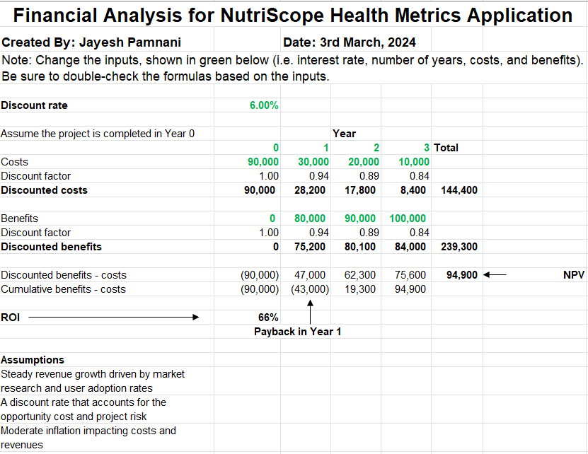

The financial analysis for NutriScope projects a strong financial performance over three years. With a discount rate of 6%, the net present value (NPV) of the project is calculated to be $94,900, indicating that the project's discounted benefits exceed its discounted costs by this amount, which signifies a positive return on investment. The initial costs are substantial at $90,000 in Year 0, but the benefits grow from $80,000 in Year 1 to $100,000 by Year 3, demonstrating an increasing value stream from the application. The costs in subsequent years are significantly lower, contributing to an overall positive financial outlook. By the end of Year 1, the project achieves a 66% return on investment (ROI), and the payback period is within the first year, suggesting that the project is not only financially viable but also likely to be profitable early on. These figures suggest a financially sound project that aligns well with the strategic financial objectives of the organization.